BioAccess®

Bone Marrow Collection System

Description:
The BioAccess Marrow Collection System is packaged as a sterile, single use system comprising the following components:
- One (1) 1500 ml Collection Bag
- One (1) Filter Set, (850, 500, 200 micron filters in set)
- Three (3) 600 ml Transfer Bags
- One (1) 2000 ml Transfer Bag
- One (1) 600 ml Anticoagulation Bag
- One (1) Extension Line (42 inch, male-to-male luer end connections)
- One (1) Adapter (male-to-male luer end connections)

Supplied by the user:
- anticoagulation solution (per institutional protocol)
- (5) Padded Hemostats
- IV pole to elevate the Collection Bag and allow gravity flow
- Table or tray to securely rest the Transfer Bags

Indications:
The BioAccess Marrow Collection System is indicated for the collection and filtering of bone marrow aspirate from a bone marrow harvest.

Warning:
Do not freeze blood product in any part of this device.

The Marrow Harvest System should only be used following strict aseptic surgical procedures.

The bags in this BioAccess Marrow Collection System are designed for the collection and filtration of bone marrow. The bags are not Substantially Equivalent to Blood Collection Bags (i.e. not intended for the collection and storage of blood and blood products).

Caution:
Federal (USA) law restricts this device to sale by or on the order of a physician.

For single use only.

Precaution:

The Collection Bag should be placed aseptically on a sturdy sterile table or tray (not provided in the kit).

Monitor the amount of volume in various bags to assure bags are not overfilled.

Make certain the Transfer Bag is securely and adequately supported on an appropriate support (not provided in kit) such as a table to prevent undue strain that could result in a disconnection and subsequent marrow loss.

If a Sterile Connecting Device (SCD) is to be used with the tubing of the Transfer Bag, the user should first ensure the tubing is compatible with the specific manufacturer of the SCD. The Transfer Bag tubing dimensions are as follows: Inner Diameter = 0.125 inches, Outer Diameter = 0.185 inches, Wall Thickness = 0.030 inches.

Do not use this product (or continue with the procedure) if there is any damage noted or leaks present during inspection.

Directions For Use:
- Use aseptic technique.
CAUTION: The Collection Bag should be placed aseptically on a sturdy sterile table or tray (not provided in the kit).
CAUTION: Monitor the amount of volume in various bags to assure bags are not overfilled.
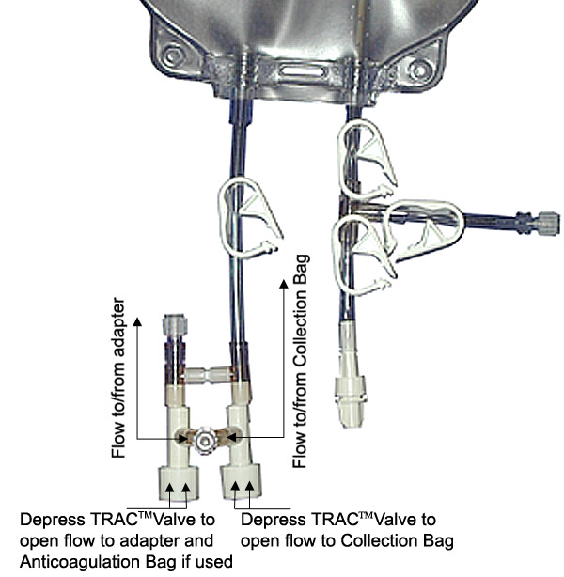
- Assure all stopcocks, clamps and caps on the Collection Bag and other components are in the closed position. Assure the TRACTM valves, stopcocks, clamps and caps are only opened as needed during the procedure. This will contain all fluid in the Collection Bag and other components during operations by the user. Retain all luer caps taken off during the procedure for later use during the procedure.
NOTE: Depressing the TRACTM valves opens a bi-directional fluid path when depressed and closes when released. The TRACTM valve needs to be depressed to allow the fluid to be expelled into the Collection Bag.
NOTE: There are two TRACTM valves attached to a “Y” connector. With the Collection Bag facing up (viewing the printing on the bag), the TRACTM valve on the right side opens (when depressed) the line to the Collection Bag. The TRAC valve on the left side opens (when depressed) the line to the female luer hub (along side the tubing). The “Y” connector will be used for insertion of marrow into the Collection Bag.
NOTE: Regarding the stopcocks used in the system, the handle of the stopcock points to the “OFF” direction.
- The Anticoagulation Bag is used by attaching the Anticoagulation Bag to the adapter connected to the TRACTM valve (opposite the Collection Bag TRACTM valve). The Adapter or Extension Line (with male-to-male connections contained in kit) will be needed to attach the Anticoagulation Bag to this adapter. This will allow the user to keep the anticoagulant solution (per institutional protocol) in a sealed container and access fluid as necessary for rinsing syringes or adding to syringes (per institutional protocol) using the TRACTM valve.
- Add anticoagulant solution to the Collection Bag and Filter Set according to institutional protocol, mixing the solution on all the interior surfaces of the components. Remember to close any valves, clamps or caps after adding the anticoagulant solution. Inspect all the components for any damage or leaks.
CAUTION: Do not use this product (or continue with the procedure) if there is any damage noted or leaks present during inspection.
- Perform marrow aspiration according to institutional protocol.
- Add the aspirated bone marrow to the Collection Bag via the “Y” adapter, attaching the syringe with marrow to the “Y” adapter. The TRACTM valve entering the Collection Bag will need to be depressed to allow flow into the Collection Bag. Also, the tubing clamp on this tube entering the Collection Bag will need to be released at this time. The Collection Bag may be gently squeezed or rocked to ensure thorough mixing of the marrow and anticoagulant.
- After the desired amount of marrow is collected or the Collection Bag is full, assemble the Filter Set to the Collection Bag. This is done by attaching the top adapter of the Filter Set to the adapter on the tubing coming from the bottom right side of the Collection Bag (while viewing the printing of the Collection Bag). Assure the Filter Set is oriented properly, with the “Top of Filer Set” printed on the Filter Set towards the Collection Bag.
- If additional bone marrow is required, the above steps should be followed using another Bone Marrow Collection System.
- A three-way stopcock comes attached to the bottom of the Filter Set. Assure the three-way stopcock is securely attached.
- Attach a Transfer Bag to the stopcock on the bottom of the Filter Set. Place the Transfer Bag on a secure area such as a sterile table or tray (not provided in kit).
CAUTION: Make certain the Transfer Bag is securely and adequately supported on an appropriate support (not provided in kit) such as a table to prevent undue strain that could result in a disconnection and subsequent marrow loss.
CAUTION: If a Sterile Connecting Device (SCD) is to be used with the tubing of the Transfer Bag, the user should first ensure the tubing is compatible with the specific manufacturer of the SCD. The Transfer Bag tubing dimensions are as follows: Inner Diameter = 0.125 inches, Outer Diameter = 0.185 inches, Wall Thickness = 0.030 inches.
- Inspect the assembled components and ensure all connections have been properly made.
- After all connections have been checked, elevate the Collection Bag above the Transfer Bag. The Collection Bag can be hung on an IV pole (not supplied in kit).
- Open the stopcocks and clamps to allow flow from the Collection Bag, through the Filter Set, into the Transfer Bag. As marrow enters the Filter Set, the Filter Set may need to be inverted to remove air.
- Allow the marrow to flow by gravity through the Filter Set into the Transfer Bag, monitoring the amount.
- If the Transfer Bag needs to be changed, the stopcock handle (on the bottom of the Filter Set) needs to be turned to stop flow coming from the Filter Set. The handle should be turned to point towards the Filter Set. The tubing clamp on the Transfer Bag needs to be put in the closed position. Do not detach the Transfer Bag before flow is stopped from exiting the system and the Transfer Bag is securely closed. Disconnect the Transfer Bag from the stopcock, leaving the stopcock (which is stopping flow) on the Filter Set. Replace the non-vented male luer cap back on the Transfer Bag adapter (and clamp or close per hospital protocol) to prevent any spillage. Attach another Transfer Bag to the same place the previous bag was located. Turn the handle on the stopcock to allow flow from the Filter Set to the Transfer Bag. Alternatively, padded hemostat clamps (not supplied in kit) may be used instead of the stopcock and tube clamps. Padded hemostat clamps (not supplied in kit) should be placed on the lower portion of the Filter Set (after the last filter in the direction of flow), and on the Transfer Bag tubing. Disconnection and reattachment of another Transfer Bag can then be achieved.
- A Filter Set can be changed if it becomes clogged. Additionally, the side tube, perpendicular to the tube exiting the Collection Bag to the Filter Set may be used with a syringe and the tube clamps to attempt to reestablish flow. This can be done by syringe aspiration (using the tube clamps) from the Collection Bag and injection into the Filter System. A new Filter Set can be obtained from another Bone Marrow Collection System. The tube clamp above the Filter Set (towards the Collection Bag) should be closed. The stopcock handle (at the bottom of the Filter Set) should be moved to stop flow from the Filter Set (handle pointing towards the Filter Set), and the tube clamp on the Transfer Bag should be closed. Do not detach the Transfer Bag or the Filter Set before flow is stopped from exiting the system (Collection Bag and Filter Set) and the Transfer Bag is securely closed. The Transfer Bag can be disconnected. The Filter Set can be disconnected from the Collection Bag and the cap can be replaced on the top of the Filter Set to avoid leakage or spillage. The new Filter Set may be reattached, and the Transfer Bag may be reattached. Check to assure the connections are made properly, then flow can be commenced by opening the tube clamp above the Filter Set (towards the Collection Bag) and opening the stopcock at the bottom of the Filter Set and assuring the tube clamp on the Transfer bag is open. Alternatively, padded hemostat clamps (not supplied in kit) may be used instead of the stopcock and tube clamps to stop flow during changing of the Filter Set. Padded hemostat clamps (not supplied in kit) should be placed above and below the connection points of the Filter Set, stopping flow in and out to the Collection Bag, Filter Set, and Transfer Bag. The Filter Set can the replaced as described above.
- When marrow filtration is complete, the Collection Bag may be rinsed with appropriate physiologic solution per institutional protocol to recover any remaining marrow.
- The tube clamp on the Transfer Bag tube should be closed. Also, the stopcock (on the bottom of the Filter Set) should be closed to avoid any spillage. Do not detach the Transfer Bag before flow is stopped from exiting Transfer Bag. Disconnect the Transfer Bag from the stopcock, leaving the stopcock on the Filter Set. Replace the non-vented male luer cap back on the Transfer Bag adapter (and clamp or close per hospital protocol).
- Follow institutional procedures for further processing.

Discard after single use. TRACTM is a trademark of B. Braun Medical
BioAccess® is a registered trademark of BioAccess Inc.

BioAccess®

Bone Marrow Collection System

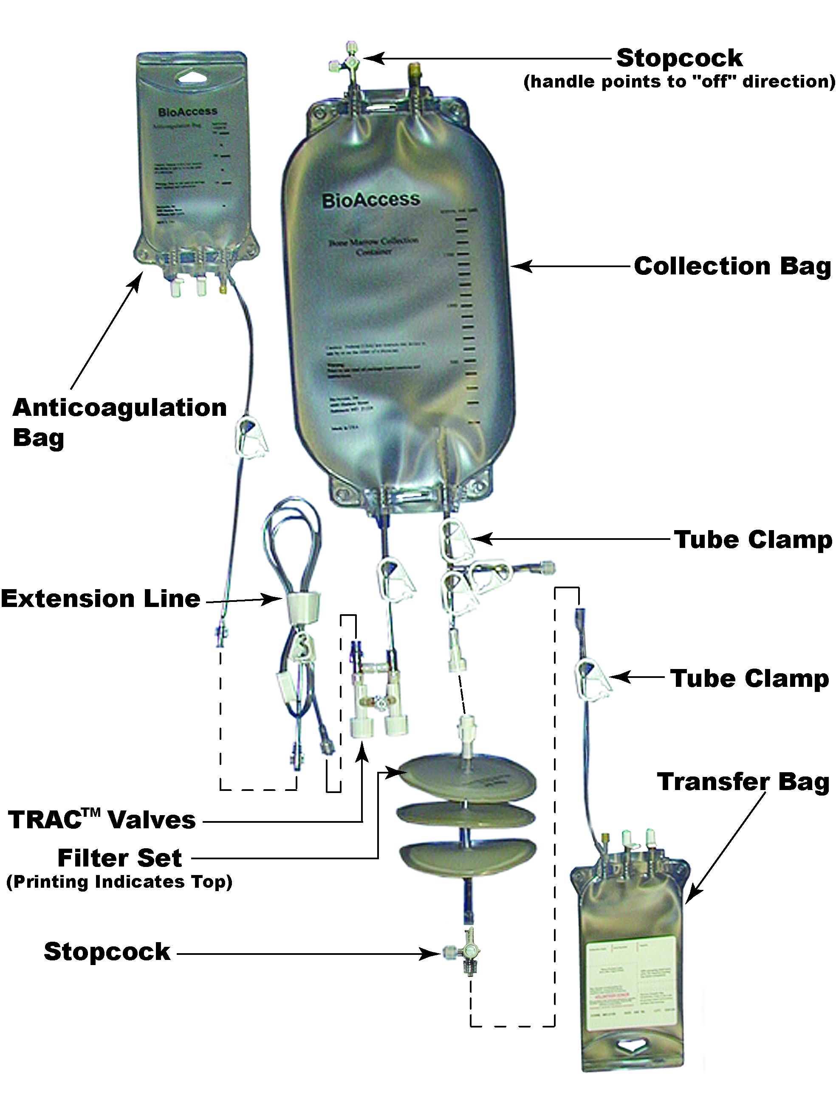
or
Adapter (male-to-male)
